1. ***Write a shell script that consists of a function that displays the number of files in the present working directory. Name this function “file_count” and call it in your script. If you use variable in your function, remember to make it a local variable. (5)***

#!/bin/bash

file_count() {

local count=$(ls -1 | wc -l)

echo "Number of files in current directory: $count"

}

file_count

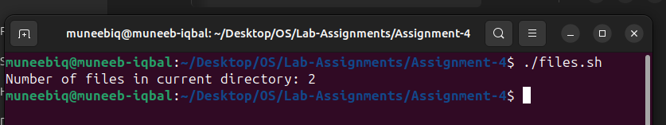

1. ***Make a function that determine the Fibonacci of an input number and print the output in the main script. (10)***

#!/bin/bash

fibonacci() {

n=$1

a=0

b=1

echo -n "Fibonacci series up to $n terms: "

for((i=0; i<n; i++));

do

echo -n "$a "

temp=$((a+b))

a=$b

b=$temp

done

echo

}

read -p "Enter the number to find its Fibonacci: " num

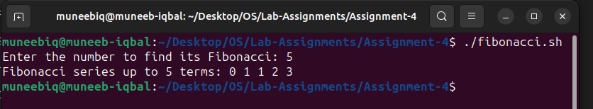fibonacci $num